The Carson Pass Sno Park (waypoint CARSON, map below) is immediately west of the pass on the south side of Hwy 88. It's noisy and busy all day and all night, mostly with truckers and sightseers. If you walk a bit into the trees you can spend the night but you'll hear jake breaks and cars stopping. This lot seems to be the usual meeting spot for day trips to Round Top, The Sisters, Elephant Back, etc.
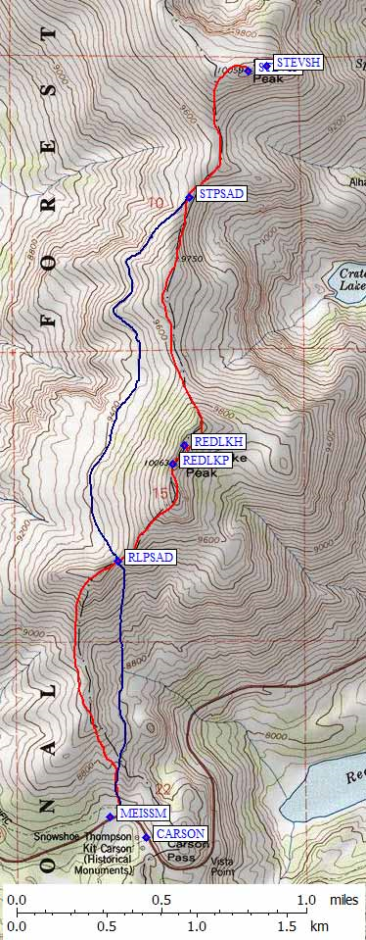
GPS route 'ROUND TOP CARSON' goes to Sisters (waypoints SISTRE and SISTRW) by way of Elephants Back (waypoint ELEBAK) and Round Top (waypoint RNDTOP). It is intended for winter use, when trails are buried and cross-country travel is easy. Elephant is trivial, I haven't done Sisters, and Round Top is easiest from the saddle (RNDSAD) just west of the summit. Between the saddle and the summit you must sometimes ascend an icy or snowpacked steep slope, walk along a rocky ridge, drop to a notch, and climb the high point to the east. A direct ridge run is 3rd class, and can be dangerous with ice and/or snow on it. You can turn the notch on the south to keep the climb 2nd class, but in some snow conditions you'll feel exposed here.
The Meiss Meadow Sno Park (waypoint MEISSM, map to the right) is about a tenth of a mile west from the Carson Pass lot, on the north side of the highway. It has less in and out traffic and seems to be more used by backcountry people. When the snow is deep, a burm between this lot and the highway cuts down some of the noise. Use this trailhead for Red Lake Peak and Stevens Peak.
GPS route 'STEVENS PK CARSON' goes to Stevens Peak (waypoint STEVNP) by way of Red Lake Peak (waypoint REDLKP). Both peaks have highpoints nearby that are NOT the location shown as the summit on the USGS maps (waypoints STEVNH and REDLKH). See Steve's trip report for winter climbing details.
Source: http://www.climber.org/DrivingDirections/TahoePasses.html#carson

